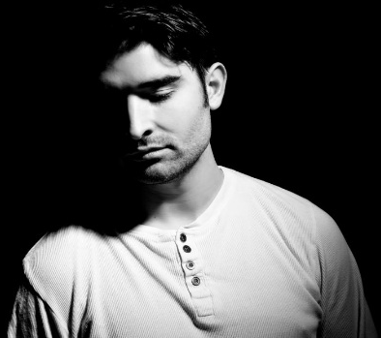
‘Shards of Glass’
32 Count, 2 Wall, Intermediate Level Line dance
Choreographed by: Karl-Harry Winson (UK)
Choreographed to: “Tell Your Heart to Beat Again” by Danny Gokey
Album: Hope In Front of Me
Intro: 16 Counts (Start on Vocals)

Side. Behind. 1/4 Turn Right. Side. Back Rock. Side Step. Behind/Sweep. Behind. 1/4 Turn Left. 1/2 Turn Left. Sweep. Back Rock.
1,2& Step Big Step to Right side. Cross Left behind Right. Turn 1/4 Right stepping Right forward. (3.00)
3&4 Step Left out to Left side. Rock Right back behind Left. Recover weight on Left. (3.00)
&5 Step Right out to Right side. Cross step Left behind Right sweeping Right from front to back.
6&7 Cross Right behind Left. Turn 1/4 Left stepping Left forward. Turn 1/2 Left stepping Right back sweeping Left from front to back. (6.00)
8& Rock back on Left foot. Recover weight on Right. (6.00)
*Tag/Restart Here on Wall 3 facing 12.00 Wall (See Modified Steps Below)

Spiral 3/4 Turn Right. Side. Cross. Side Rock. Cross. Side. 1/8 Turn Right. Diagonal Back Step. Touch/Look.
Forward Step. Hinge 5/8 Turn Left.
1 Step Left forward, Pivot 3/4 turn Right hooking Right across Left foot. (3.00)
2&3& Step Right to Right side. Cross Left over Right. Rock Right out to Right Side. Recover weight on Left.
4&5 Cross Right over Left. Step Left to Left side. Turn 1/8 Right stepping Right foot back on the diagonal (facing 4.30 Diagonal).
6 Touch Left beside Right and look over Right shoulder turning body slightly to the Right as you do this.
7&8& Step Left forward (to 4.30 Diagonal). Turn 3/8 Left Stepping Right back (12.00). Turn 1/4 Left stepping Left to Left side (9.00). Cross step Right over Left. (9.00)

Basic NC Left. Side. Behind-Side-Cross. Right Prissy Walk. Step. Pivot 1/2 Turn Right. 1/2 Turn Right. Back. Cross.
1,2& Step Left foot out to Left side. Rock back on Right. Recover weight on Left slightly crossing over Right.
3 Step Right out to Right side.
4&5 Cross Left behind Right. Step Right out to Right side. Cross step Left over Right.
6 Walk forward on Right crossing Right over Left (slightly hitch knee as you do this).
7&8 Step Left forward. Pivot 1/2 Turn Right. Turn 1/2 Turn Right stepping Left back. (9.00)
&1 Step back on Right (angling body slightly to diagonal). Cross step Left over Right.

Back-Together. Cross Rock. Ball-Cross. Step 1/4 Turn Left. Cross Rock. Side. Cross Step.
2&3 Step back on Right (straightening up to 9.00). Close Left beside Right. Cross Rock Right over Left.
4&5 Recover weight back on Left. Step Right beside Left. Cross step Left over Right.
6&7 Step Right to Right side. Pivot 1/4 turn Left. Cross Rock Right over Left. (6.00).
&8& Recover weight on Left. Step Right out to Right side. Cross step Left over Right. (6.00).
(1) Step Big Step to Right side to start dance again.

*Tag/Restart: On Wall 3 (12.00) during Section 1, to keep you on the 12.00 Wall Modify Counts 7&8& to the following steps:
Pivot 1/2 Turn Left X2
6& Cross Right behind Left. Turn 1/4 Left stepping Left forward. (12.00)
7& Step forward on Right. Pivot 1/2 Turn Left. (6.00)
8& Step forward on Right. Pivot 1/2 Turn Left. (12.00)

**Tag: The Following 4 Count tag happens at the end of Wall 5 facing 12.00 Wall.
Basic NC Right. 1/4 Turn Left. Step. Pivot 3/4 Turn Left.
1,2& Step Right to Right side. Rock back on Left. Recover weight on Right crossing Right slightly over Left.
3,4& Turn 1/4 Left stepping Left forward (9.00). Step Forward on Right. Pivot 3/4 turn Left. (12.00)

